Setup cont.

Install Tmux

Using <https://linuxize.com/post/getting-started-with-tmux/>

For Ubuntu type “Sudo apt install tmux”

For centos “sudo install tmux”

Type tmux to start

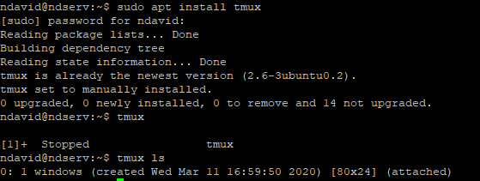

Installing EMACS

Type Sudo apt get emacs 26.2

Type emacs to open

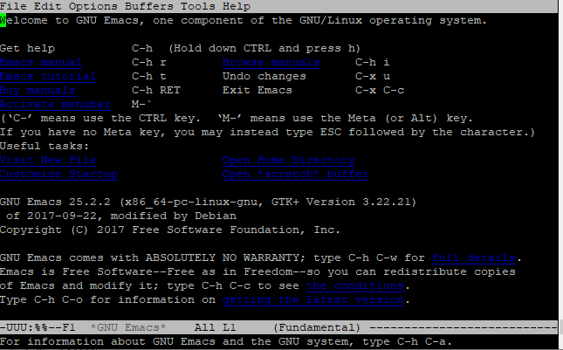

Installing Fail2ban’

Type sudo apt-get update

Type sudo apt-get upgrade

Type sudo apt-get install –y fail2ban

Start/enable fail2ban

Type Sudo systemctl start fail2ban

Type Sudo systemctl enable fail2ban

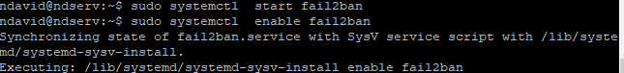Configuring a jail for ssh login attempts

Type sudo nano /etc/fail2ban/jail.com

And paste:

[sshd]

enabled = true

port = 22

filter = sshd

logpath = /var/log/auth.log

maxretry = 3

restart fail2ban with this command sudo systemctl restart fail2ban

now if anyone try’s to logon more than three times as root and fails they are banned

Installing VIM type Sudo apt-get install VIM

And you should be all set and ready to go!